Electromagnetic Induction- Class 9

Introduction :

Imagine plunging your hand into the invisible, touching the intangible, and harnessing an unseen force to light up cities and drive the energies of industry. This isn’t stuff of magic or alchemy but the extraordinary world of electromagnetic induction. It is a concept so revolutionary that it transformed the mere curiosity of electricity into the powerhouse of the industrial revolution and beyond.

Electromagnetic induction is the process by which a change in the magnetic environment of a coil of wire induces an electromotive force (EMF) or voltage in the coil. It doesn’t require the wires to be in contact with the magnetic material; rather, the phenomenon is all about the movement and interaction of magnetic fields and conductors.

Relevant concept introduction to the model :

Magnetic lines of force :

Magnetic lines of force also known as magnetic field lines, are imaginary lines used to represent the strength and direction of a magnetic field. They provide a visual way to depict the magnetic field around a magnet or any magnetic material.

* Lines of force originate from the north pole of a magnet and terminate at the south pole. In case of bar magnet, these lines exit from the north pole, curve around the magnet and enter at the south pole.
* These lines never intersect each other.
* The density of the lines indicate the strength of the magnetic field. In digital content , it is depicted with subtle colour variations
  + Red to the poles and stronger magnetic field
  + Green/ Blue to the curvature and relatively less magnetic field
* Magnetic field lines are always closed loops. Every magnetic field line that exits a north pole will enter a south pole and continue through the material to the north pole again.

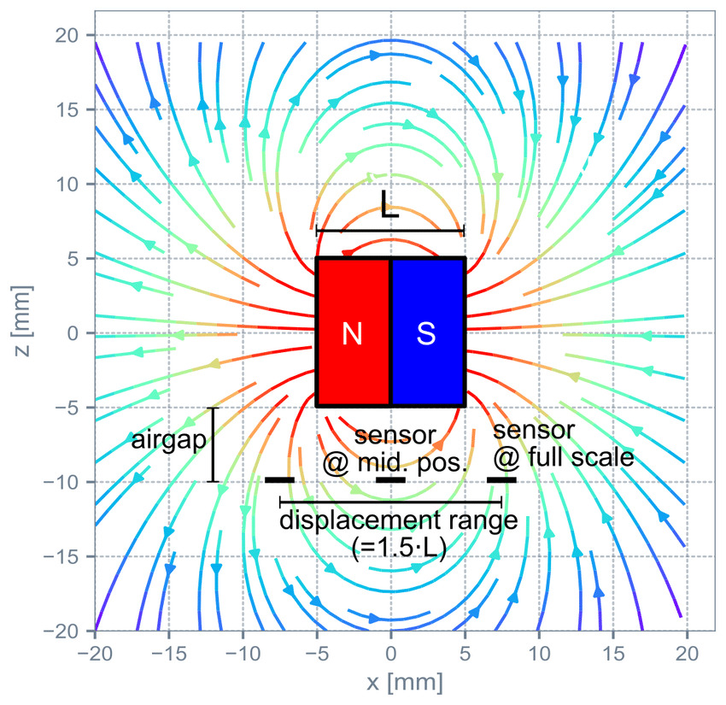

Electromotive force :

Electromotiv force (EMF) is the source of energy that pushes electrons through a conductor and can be generated by various methods, including chemical reactions in batteries, In this case, induction in generators.

Magnetic flux :

Magnetic flux is one of the fundamental concept in electromagnetism, it refers to the total magnetic field passing through a specific area. It is a way to quantify how much of the magnetic field passes through a particular surface.

The electromotive force induced in a circuit is directly related to the rate of change of magnetic flux through the circuit.

Lenz’s law :

Named after the German physicist Heinrish Friedrich Emil Lenz who formulated Lenz law in 1834, gives the direction of an induced electromotive force (EMF) and current resulting from electromagnetic induction.

It states that the direction of the induced EMF and current in a closed circuit is such that it opposes the change in magnetic flux that produces it. This law is a manifestation of the conservation of energy as applied to electromagnetic systems.

To understand Lenz law, a scenario was depicted in the digital content.

When you move a magnet towards a coil the magnetic flux through the coil increases. According to Lenz’s law, the coil will generate an induced current whose magnetic field opposes the increase in magnetic flux. If the magnet’s north pole is approaching the coil, the coil’s induced magnetic field will also have a north pole facing the approaching magnet, effectively repelling it. This opposition requires additional work to bring the magnet closer, demonstrating energy conservation.

Working explanation of the model :

The model used for the explanation, is a simple generator, is a machine that converts mechanical energy into electrical energy using the principles of electromagnetic induction. The primary components that make up a typical generator include

* Armature
* Permanent magnets
* Commurtator and brushes.

Each component plays a crucial role in ensuring efficient operation.

Armature :

The rotor, known as the armature, is the rotating part of the generator. It consists of coils of conductive wire that rotate within the magnetic fields. This rotation cuts the magnetic lines of force from the permanent magnet, inducing an electromotive force across the conductors due to electromagnetic induction.

The rotor’s primary function is to producer electricity as it rotates within the magnetic field. The electrical output is taken to the LED connected through contacts ( either slip rings or a commutator ) connected to the rotor.

Permanent magnets :

The purpose of the permanent magnets is to create a magnetic field in which the rotor or armature rotates. The interaction between the magnetic field and the motion of the rotor leads to the generation of electricity.

Commutators and brushes :

A commutator is used in DC generators . It reverses the connection of the rotor windings to the external circuit during each half rotation, producing a direct current instead of alternating current.

The commutator switches the direction of current flow in the rotor coil windings each time the coil passes through them.

Brushes are typically made of carbon, maintaining sliding contact between the stationary and rotating parts. They allow the rotor ro spin while still maintaining an electrical connection throught the rotor windings to the external circuit. They transfer the voltage out into the LED connected.

The interaction between the rotor, stator, and field magnets, facilitated by the commutator and brushes, allows for the efficient conversion of mechanical energy into electrical energy. The faster the magnetic field changes, the greater the voltage induced in the circuit.

History :

Hans Christian Orsted :

The foundational observsation for electromagnetic induction was made by Physicist Hans Christian Orsted in 1820. He discovered that a compass needle was deflected when placed near a wire carrying an electric current, demonstrating a link between electricity and magnetism.

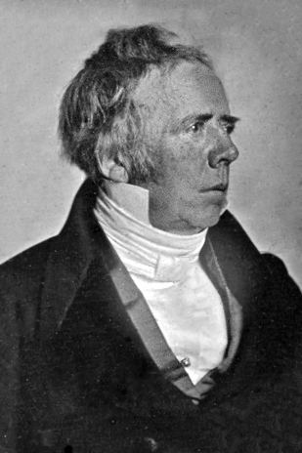

Micheal Faraday and Joseph Henry :

In the early 19th century, Faraday made his groundbreaking discovery during a series of experiments. He observed that when he moved a magnet through a loop of wire, an electric current flowed in the wire while the magnet was in motion. This essence of electromagnetic induction was described with Faraday’s laws of induction

Faraday’s Law of Electromagnetic Induction : This law states that a change in the magnetic field within a loop of wire induces an electromotive force (EMF) in the wire.

Faraday’s Right Hand Thumb Rule : The right hand is held with the [thumb](https://en.wikipedia.org/wiki/Thumb), [index](https://en.wikipedia.org/wiki/Index_finger) finger, and [middle finger](https://en.wikipedia.org/wiki/Middle_finger) mutually perpendicular to each other (at right angles), as shown in the diagram.

* The thu**m**b is pointed in the direction of the **m**otion of the conductor relative to the magnetic field.
* The **f**irst finger is pointed in the direction of the magnetic **f**ield. (north to south)
* Then the se**c**ond finger represents the direction of the induced or generated **c**urrent within the conductor (from + to -, the terminal with lower [electric potential](https://en.wikipedia.org/wiki/Electric_potential) to the terminal with higher electric potential, as in a voltage source)

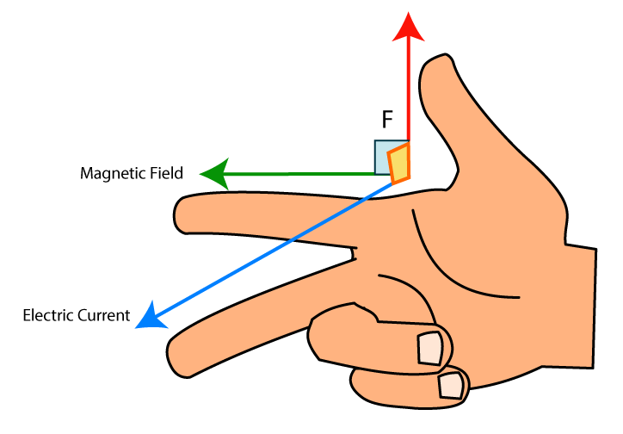

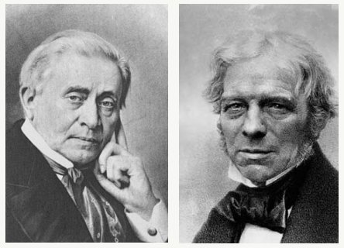

Joseph Henry Michael Farady

James Clerk Maxwell :

In 1860s, Maxwell formulated his set of equations known as Maxwell’s Equations, which mathematically described how electric and magnetic fields are generated and altered by each other as well as by charges and currents. His equations also predicted the existence of electromagnetic waves and showed that light itself is an electromagnetic wave, thus unifying the concepts of electricity, magnetism, and light.

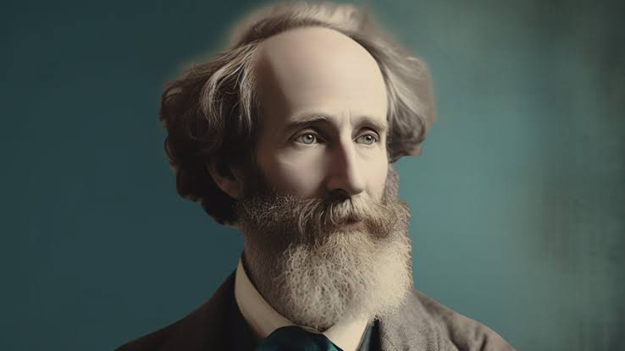

Applications :

The applications of electromagnetic induction range from power generation and propulsion systems to scientific instrumentation and data collection.

Electromagnetic induction generators : These are used on spacecraft equipped devices that convert mechanical motion into electrical energy. For example, if a spacecraft has parts that rotate or if it can harness kinetic energy from other sources, electromagnetic induction can be used to generate power.

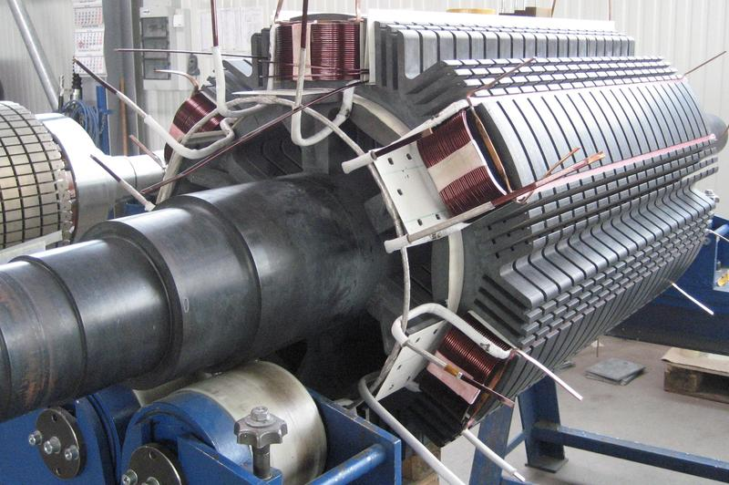

Electrodynamic Tethers : These are long conduction cables that can be deployed from a spacecraft to interact with a planet’s magnetic field to generate electricity and propulsion. As the tether cuts through the Earth’s magnetic field, an EMF is induced across the length of the tether, which can be used for power and also to change the spacecraft’s orbit without using fuel.

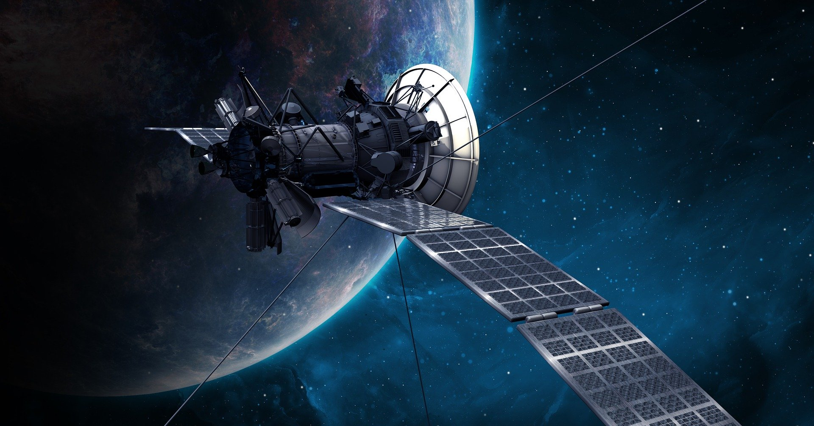

Magnetometers : These are used on satellites and space probes to measure the strength and direction of magnetic fields in space. Understanding magnetic fields is crucial for studying planets, moons, and solar wind interactions. These devices often work based on the principles of electromagnetic induction, detecting changes in magnetic fields that induce currents in coils within the instrument.

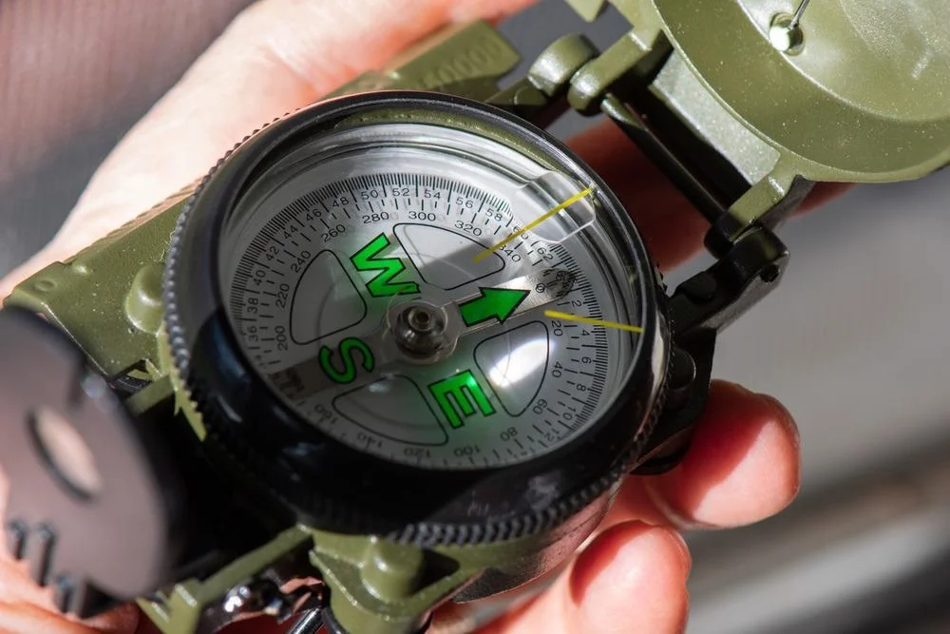

Metal Detectors : Similar in principle to their Earth counterparts, these are used in robotic missions to asteroids, moons, or other celestial bodies to detect metal resources. They work based on electromagnetic induction to identify metal objects beneath the surface.

